RB01- Create IGW and TGW

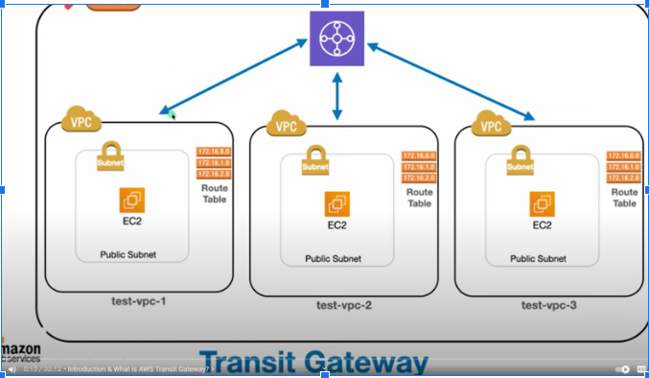

1. Create 3 VPCs 12.0.0.0/16 & 13.0.0.0/16 & 14.0.0.0/16
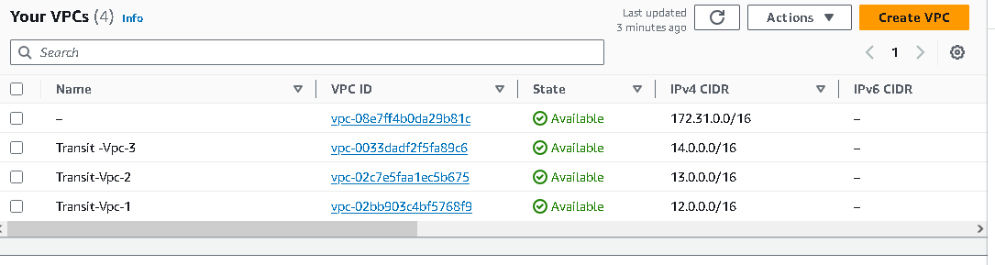
2. Create 3 IGWs (one for each VPC) and attach it to each VPC

3. Create 3 public Subnets(one subnet for each VPC)
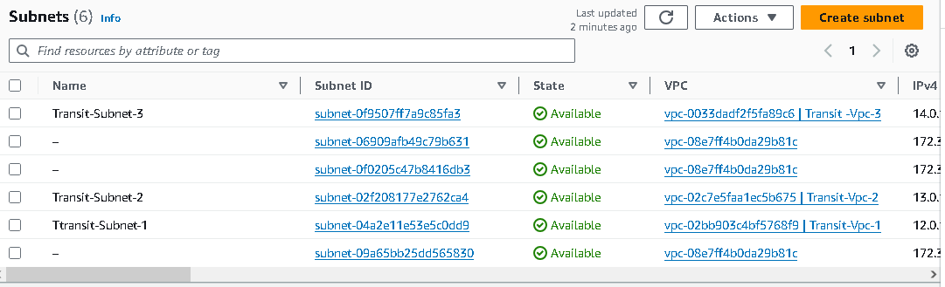

4. Create 3 Route-tables (one for each VPC) and associate it with related subnet
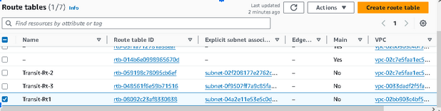

5. Create routes in each route-table and add route to IGW

6. Create 3 EC2 one for each subnet with SG (ssh & http) + Enable Public IP + userData
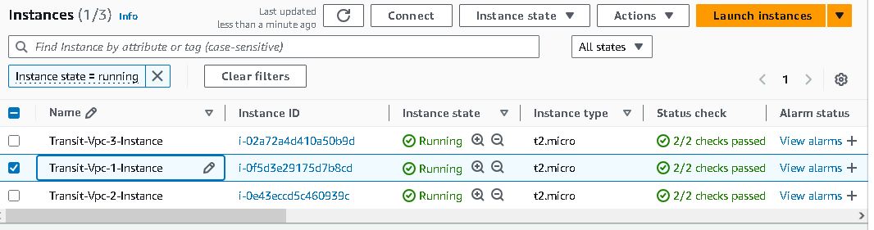

7. Create Transit-Gateways(from VPC Console)
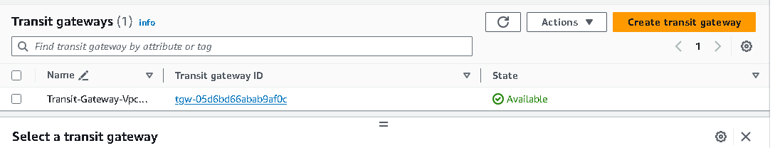

8. Create 3 Transit-Gateway Attachments(from VPC Console)one for each VPC
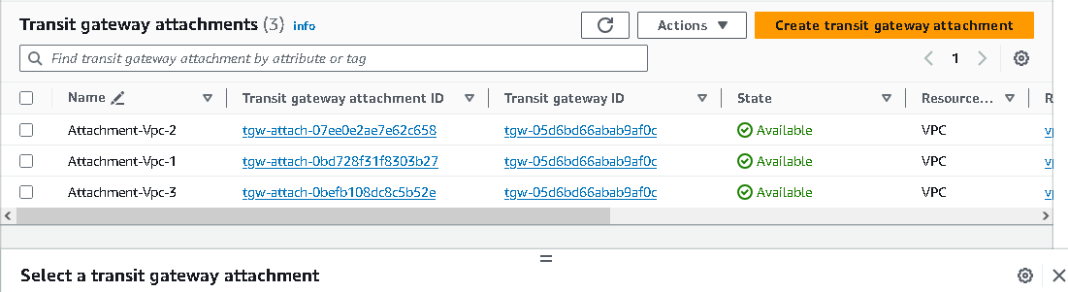

9. Edit route-tables and add 2 routes in each with a destination (CIDR rang of other VPCs) & target of related target-gateway.
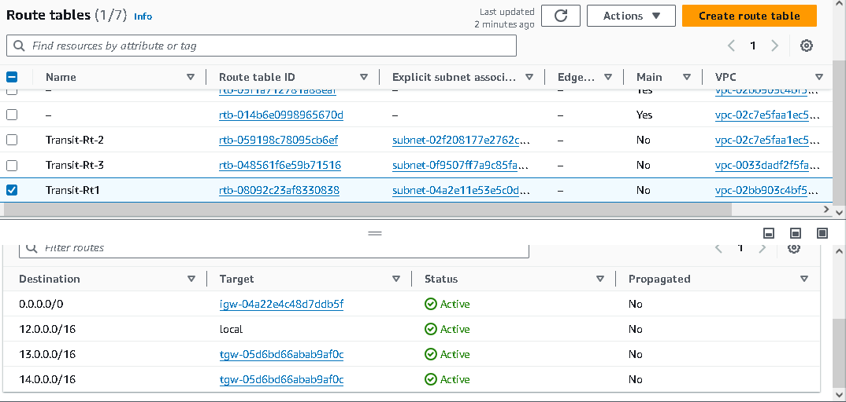

12. Edit RT2 & Add route for CIDR range of VPC1

Testing from terminate try to ssh on first ec2 instance (SSH Client)
1. chmod 400 keypair-ec2-from-VPCx

2. ssh to first ec2 and try to curl private ip of second ec2 and third ec2
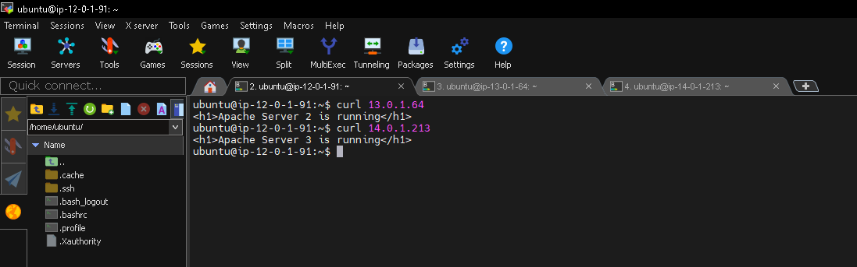

ssh to second ec2 and try to curl private ip of first ec2 and third ec2
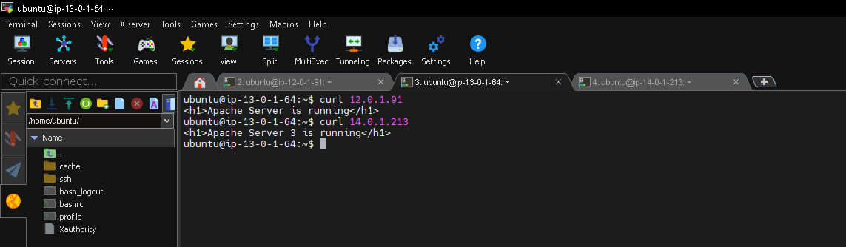

ssh to second ec2 and try to curl private ip of first ec2 and third ec2
